December Panther Press – High School
December
1-3 Theater Program Fall Production – ‘It’s A Good Life-Live Broadway Show’
4-15 NHS Holiday Food Drive
4-1/19 Winter MAP Testing Window
11 Holiday Band Concert, 7pm
13 NHS Talent Show, Advisory
18 Board of Education Meeting, 7pm
19 Holiday Choir Concert, 7pm
21 CPHS Semester Final Exams – 4th, 5th, and 6th hour – Students dismissed at 11:00am
22 CPHS Semester Final Exams – 1st, 2nd, and 3rd hour – Students dismissed at 11:00am
25-1/5 Holiday Break – No School
January
1-5 Holiday Break – No School
8 First Day of Second Semester
11 Junior Class MME/State Testing Meeting, Advisory
15 Board of Education Meeting, 7pm
16 Parent Advisory council Meeting, 7-8:30pm
20 Dodgeball Tournament
25 Senior Class Meeting – Graduation Planning Meeting, Advisory
26 Winter Spirit Week Kickoff Assembly, Advisory
29-2/3 Winter Spirit Week

It’s A Wonderful Life – Live Radio Show
Congratulations to the cast, crew, and directors for their performance of “It’s A Wonderful Life-Live Radio Show” on December 1st through December 3rd. This holiday classic is a show within a show. The cast did an amazing job. The choreography and flow of the play were seamless. The audience had warm fuzzies at all the same beloved moments. The young talent at Comstock Park has really developed over the past few years. If you haven’t experienced a play recently you should come to our next play scheduled for April.

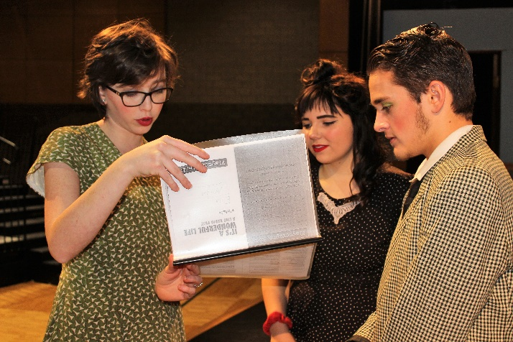
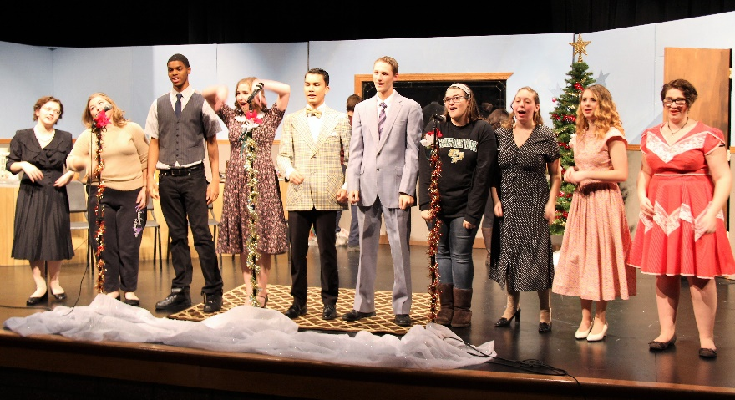

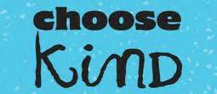

Kindness Week at the High School
The Student Volunteers launched a new initiative this year, ‘Kindness Week’. It started with a hat and mitten drive benefitting our CP community and followed with sending ‘Thank You’ cards to students, staff, and our military. Throughout the week students and staff were encouraged to fill out thank you cards at stations set up in the lounge and cafeteria. Future “Keep Kind” days have been scheduled this year to keep awareness going and provide opportunities to spread kindness. Remember, a random act of kindness can make all the difference in someone’s life.
